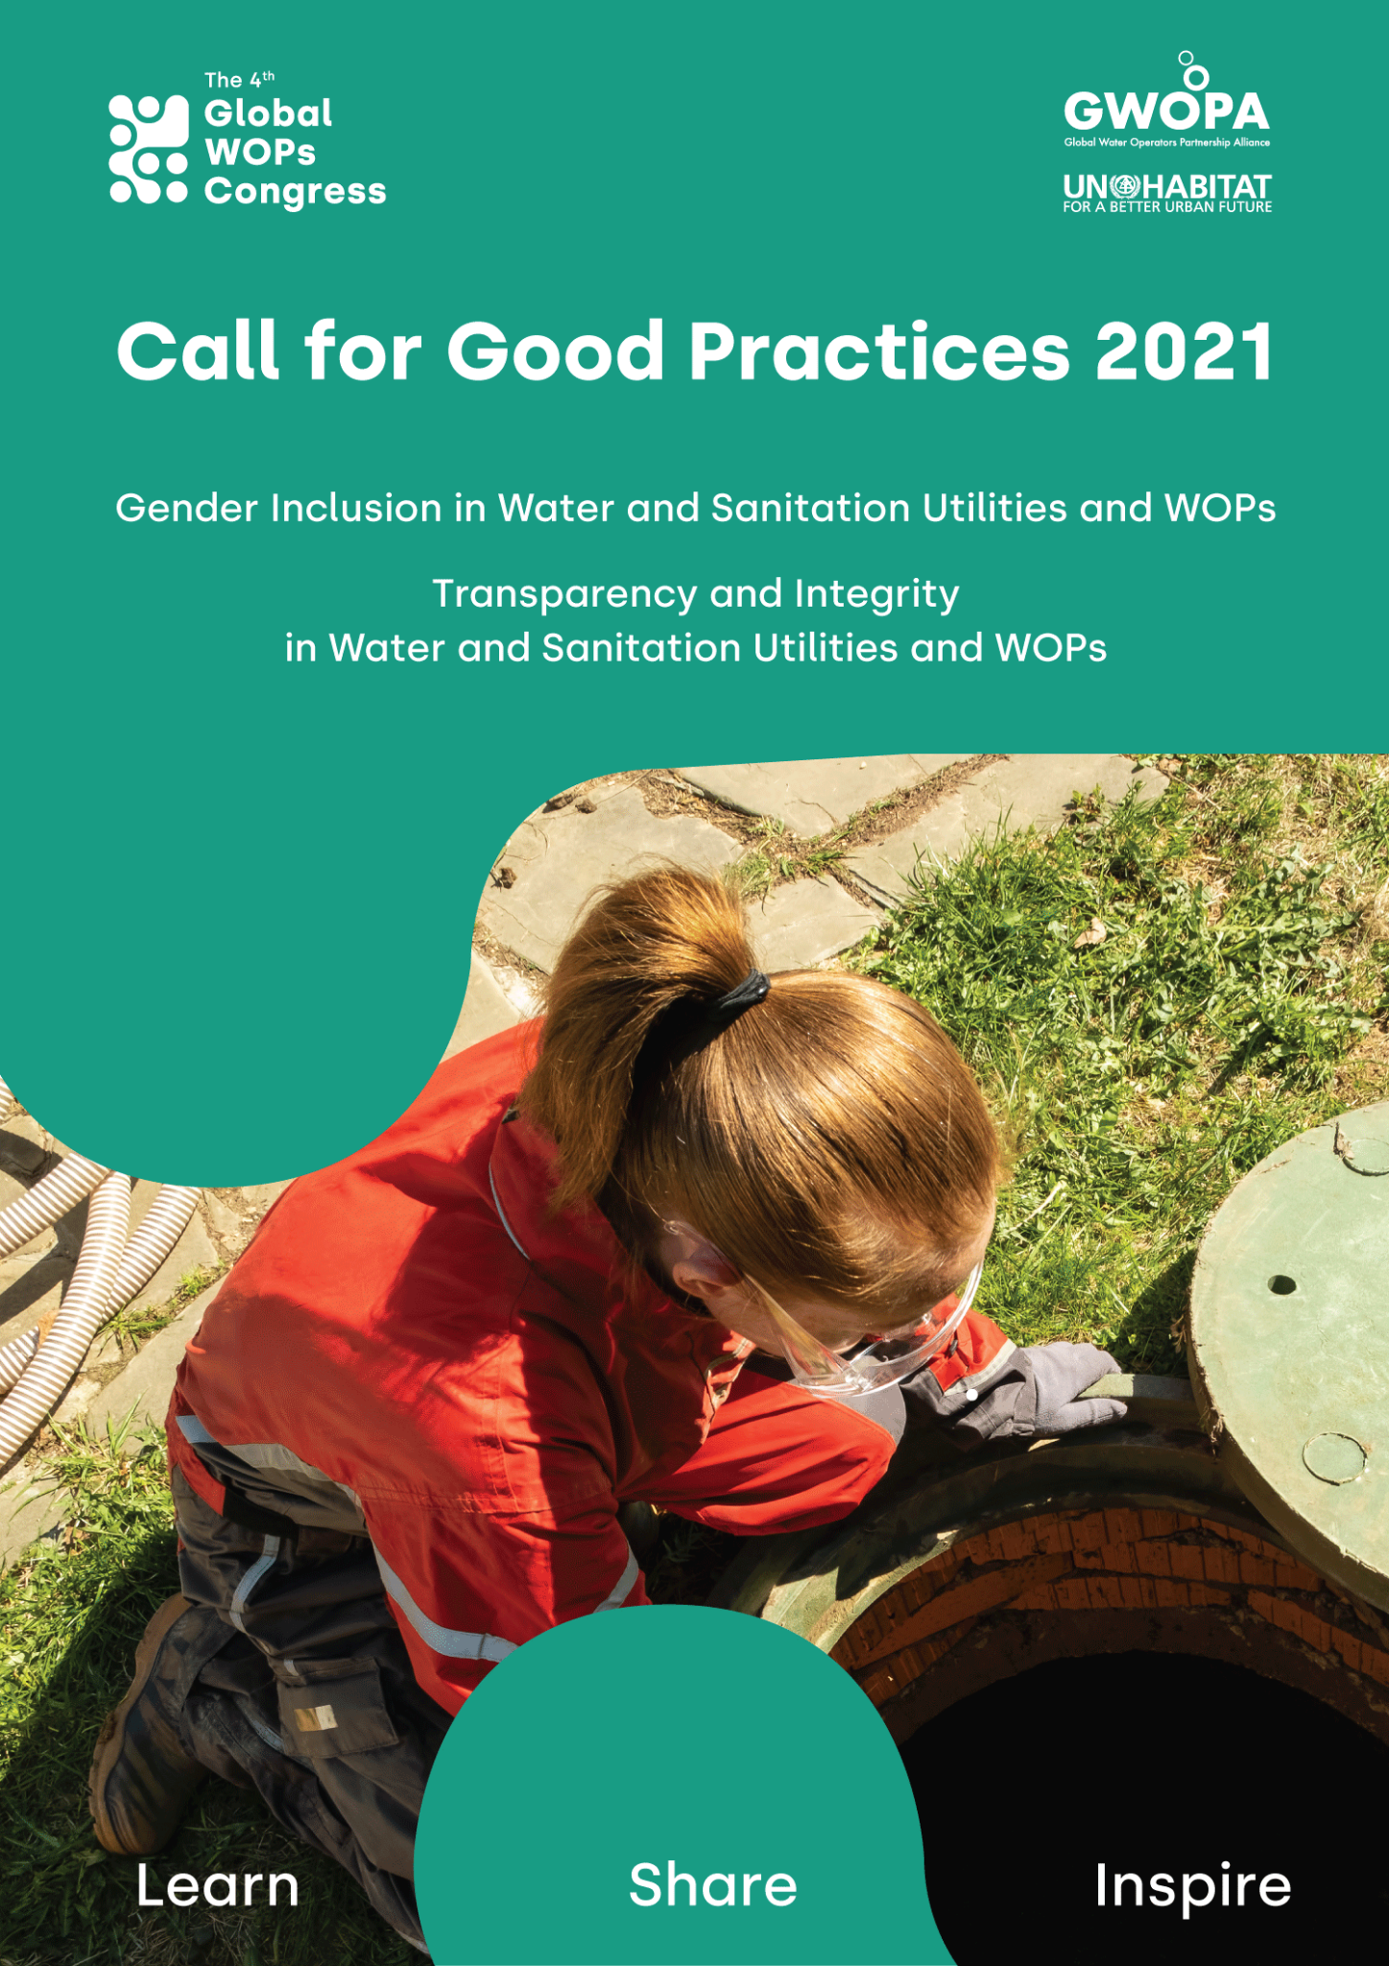

GWOPA/UN-Habitat is calling for submission of Good Practices on the following categories:

- Gender Inclusion in Water and Sanitation Utilities and WOPs

Women are under-represented among water and sanitation service professionals. At the same time, water and sanitation utilities often fail to take gender sufficiently into account in the planning, financing, delivery and evaluation of services, with negative consequences for women and girls in particular. Practices in this area may include gender-sensitive approaches in service provision, promoting gender inclusion in the workforce, or ways in which Water Operators Partnerships have helped develop capacity for gender inclusion.

- Transparency and Integrity in Water and Sanitation Utilities and WOPs

Within water and sanitation utilities, good governance is key for a fair and sustainable management of water and sanitation. Poor accountability, transparency, and the lack of integrity often causes underperformance and generates unnecessary losses. It also prevents investments to go where they should, obstructing the achievement of fair and equal water access for all.

Transparent information sharing and integrity allows a healthy exchange of knowledge within and between water and sanitation operators and upholds accountability towards their customers and other stakeholders. It also enables water practitioners to have a stronger engagement in the Utilities’ and WOPs’ goals and for them to easily capture capacity improvements.

Integrity, specifically in WOPs, is the sharing of knowledge in a not-for-profit and unrestrained way, built upon the notion of solidarity between utilities. Its purpose is to enhance the capacity and capability of public utilities, guide by integrity as a core value.

Practices in this area, for water utilities and WOPs, may include transparency mechanisms, accountability and integrity tools and processes, ways of improving participatory governance, and plans to fight against corruption.

Objectives
The main objective of the Call is to raise awareness on the importance of Gender Inclusion and Transparency in water and sanitation service provision and Water Operators’ Partnerships. The call aims to identify, celebrate and encourage sharing of these good practices between water and sanitation utilities.

Outcomes
Selected Good Practices will be shared in the framework of the 4th Global WOPs Congress. The winners will be published on the UN-Habitat’s and the Global Water Operators’ Partnerships Alliance (GWOPA)’s websites and shared with members of the Alliance through the newsletter, social media channels and the Congress platform. Selected applicants may participate in interviews upon request.
Evaluation Criteria and Process
The submissions will be evaluated by the Selection Committee* using the following core criteria:

- The approach/activities are relevant to challenges faced
- The practice is coherent and fits in harmony and synergy with related activities
- The practice is effective, making positive and sustainable impacts on beneficiaries
- The practice involves innovative solutions/approaches that accelerate sustainable responses to ongoing challenges.
- The activities/practice can be applied or adapted by other water/sanitation utilities or within Water Operators’ Partnerships

* The Selection Committee will be comprised of members from GWOPA/UN-Habitat, the GWOPA International Steering Committee and/or WOPs Regional Platforms

How to participate
To participate, please:

- Fill the Application Form in one of the following languages: French, English, or Spanish
- Include up to four pictures in the submission. They should have copyright clearance and a suggested caption. The images size should be between 1500 and 2500 pixels wide.
- Send all documents as attachments to info@gwopa.org before 12 October, midnight CEST.

Should you have any doubt or enquiry, please do not hesitate contact us at the same email.

APPLICATION FORM
Kindly use the font Calibri (Body), font size 12

SELECT THE CATEGORY OF THE GOOD PRACTICE

Gender Inclusion in Water Utilities and WOPs

Transparency and Integrity in Water Utilities and WOPs

AUTHOR/SUBMITTER DETAILS

Name (Surname, First name)
Country of residence
Organization
Job position
E-mail address

TITLE OF THE GOOD PRACTICE
Maximum 10 words

DESCRIPTION OF THE GOOD PRACTICE
Please give a brief overview of the good practice (what), including brief context, and why (relevance), how, when, where and by whom the initiative was implemented. Maximum 250 words

OBJECTIVES AND ACTIVITIES
Please describe the overall goal of the initiative and its activities and milestones in chronological order as well as the relation to other activities within the water utility or WOP. Please provide details about innovative solutions, if applied. Maximum 300 words

RESULTS AND IMPACT
Explain how the good practice contributes to results and impact in the selected category (gender inclusion in water utilities and WOPs, or transparency and integrity in water utilities and WOPs). Please make sure to indicate, wherever relevant, impacts on: ultimate beneficiaries, utilities’ staff, awareness, capacity development, investment and services. How sustainable have they been? Maximum 500 words

TRANSFERABILITY
Please indicate how your practice might be applied by other utilities or in WOPs. Maximum 250 words

KEY ACTORS INVOLVED
How the different actors were involved in the design and implementation of the good practice. Maximum 300 words

ADDITIONAL INFORMATION
To support your application, please add:
- Photos (from 1-4 photos are required. See submission instructions above)
- Links to post(s) in social media and/or;
- Links to YouTube video(s) and/or;
- Print (as attachment) or online (link) published materials – article, brochure, leaflet, etc.

Date:

By submitting this good practice for the Call, the author allows GWOPA/UN-Habitat and its partners to use and publish the information and the submitted content for various purposes and in different formats

